LINUX-TASK 01

1. $ / (Forward slash) showing root directory
2. $ ~ (Tild) home directory
3. $ PWD (Present working directory)
4. PWD = present working directory.
5. CD = Change directory location.
6. MKDIR = Create directory.
7. LS = shows list of files available
8.LL = shows that all files and directories are available.
9.RM -RF = delete a directory.
10. Touch = create a file.
11. RM = delete a file
12.MV = editing directory
13. LS -A = shows hidden files
14. VI = creates a file and open the editor
15. CAT = to read the content in the file.
16. WC = read the word count and to know how many files are available.
17. DATE & TIME.
18.vi <file> : It is an editor used to open the file.
19.wq! : To save the file
20. cat : It is used to read the content of the file.
21. wc : It is used to show the word count of the file.

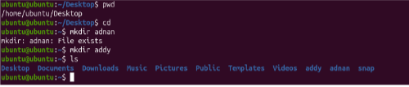
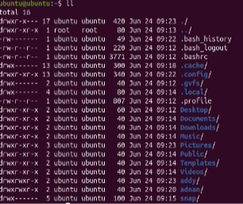
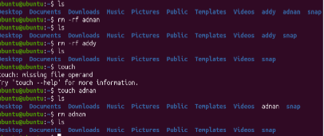

$History (all commands used)
